Feasibility Study Summary
I downloaded an Amazon reviews dataset to test if it is suitable for analyzing relationships between review text, rating, and time of day. The dataset contains over 700,000 reviews, each with a star rating, full review comment, and a timestamp

Sentiment vs. Rating
First test is to check whether the sentiment of the written review text matched the star rating. Using the Bing sentiment lexicon, we can prove the functionality of the dataset by calculating the average sentiment score for each rating level.
Graph: Average Sentiment Score by Rating
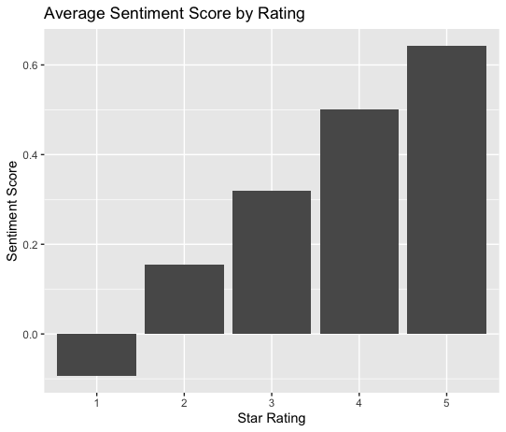

This graph shows a clear upward trend:
- 1-star reviews are slightly negative,
- 2–3 stars are moderately positive, and
- 4–5 stars are strongly positive.
This confirms that the text meaningfully reflects the rating and that the dataset behaves as expected.

Sentiment vs. Time of Day
Second test us to check whether reviews written later in the day were more negative than reviews posted in the morning. Time of day was formatted to 24 hours with this range (0–23) from each timestamp and calculated the average sentiment score for each hour.
Graph: Average Sentiment Score by Hour of Day
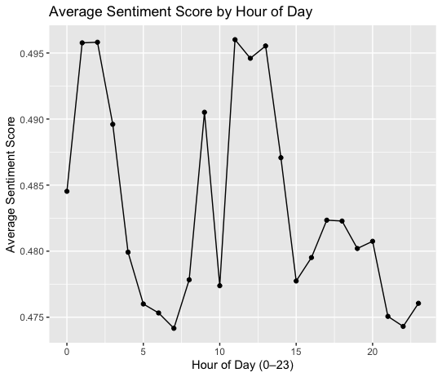

The line fluctuates slightly throughout the day, but the overall sentiment stays within a very narrow range (about 0.47 to 0.50). There is no clear pattern where reviews become more negative at night. Sentiment remains fairly steady regardless of the hour.

Conclusion
The dataset is fully feasible for text-based and sentiment-based analysis. Review text matches star ratings, and timestamps are correctly formatted and usable. While time of day does not appear to influence sentiment in a major way, the dataset provides everything needed for further modeling and analysis.

